EENG 385 - Electronic Devices and Circuits

Frequency Response: Total Harmonic Distortion

Lab Handout

Objective

The objective of this lab is to measure the total harmonic distortion of the audio amplifier using the FFT feature of the oscilloscopes.

Reference: W2AEW: Measuring Total Harmonic Distortion THD using an FFT on an oscilloscope #305

# Total Harmonic Distortion:

A good audio amplifier should faithfully reproduce audio input to the speaker. One way to measure this is quality is total harmonic distortion (THD). THD measures the power of the harmonics over the power of the fundamental frequency as a percentage. You will measure THD by applying a sine wave at some input frequency and measure the energy contained in the fundamental frequency and all higher harmonic frequencies. Let’s explore these ideas with the help of Figure 1.

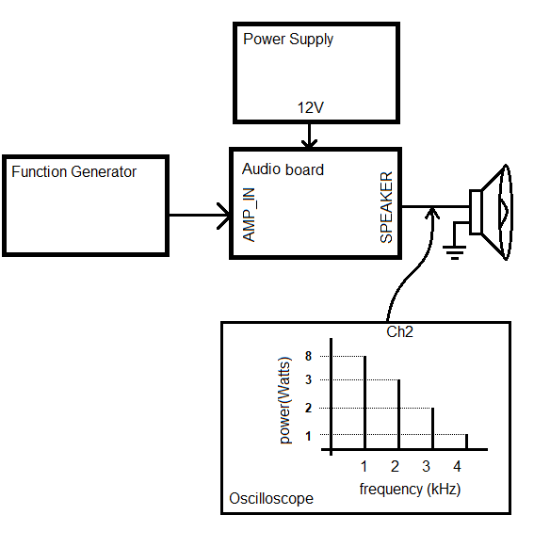

Figure : Setup to measure THD of the Audio Amplifier.

The Function Generator in Figure 1 is sending a 1kHz sine wave into the AMP_IN of the Audio board. - the amplitude of the input waveform is unimportant. We will assume that the function generator generates perfect sinusoidal inputs (according to the Rigol DG1022Z datasheet, its THD is less than 0.2%). It’s important that you power the Audio board using the bench power supplies – this will reduce spurious noise injected into your Audio board through the power input. The oscilloscope in Figure 1 will examine the output of the Audio board using it’s FFT function. This will let us measure the power of the fundamental 1kHz output and the unwanted harmonics at 2kHz, 3kHz and 4kHz. Using the (unrealistic) values in the Figure 1, the fundamental power is 8 Watts and the sum of the power in the harmonics is 3W+2W+1W = 6 Watts. Thus, the ratio of the power in the harmonics over the fundamental is 6W/8W = 0.75. Since THD is measured as a percentage, we must multiply this value by 100, yielding a THD of 75%. This means that 75% of the amplifier’s power is being used to generated spurious signals – making a very poor audio amplifier. The oscilloscope in Figure 1 is configured to measure the FFT of the output. The question is how can you extract the power information from the FFT values? Good question, let’s explore this.

We start by transforming the definition of THD into a mathematical form using the definition of THD given earlier in Equation 1 – we will convert this ratio into a percentage in a later step. Note that the resistive load R is the 8Ω speaker in Figure 1.

|  |  |
| --- | --- |
| $$THD=\frac{\sum{Power in Harmonics}}{Power in Fundamental}=\sqrt{\frac{P_{2}+P_{3}+P_{4}+…}{P_{F}}}$$ | 1 |

The $P_{i}$ terms in Equation 1 are the power of ith harmonic. $P_{F}$ is the power in the fundamental, 1kHz in Figure 1. In the example from Figure 1 $P_{F}=8W$ and $P_{2}=3W$. In your first EE course you learned that the average power delivered to a resistive load of R ohms by a waveform with RMS voltage $v_{RMS}$ is given by Equation 2.

|  |  |
| --- | --- |
| $$P_{i} =\frac{v_{i}^{2}}{R}$$ | 2 |

We will substitute Equation 2 for each of the $P_{i}$ terms and for $P_{F}$ in Equation 1. When we do this, there will be a common R term (the 8Ω load) in each of the numerator terms and in the denominator. Multiplying the numerator and denominator by R, eliminates this term and yields Equation 3.

|  |  |
| --- | --- |
| $$THD=\sqrt{\frac{P_{2}+P_{3}+P_{4}+…}{P_{F}}}=\sqrt{\frac{v_{2}^{2}+v_{3}^{2}+v_{4}^{2}+…}{v_{F}^{2}}}=\sqrt{v_{2}^{2}/v_{F}^{2}+v_{3}^{2}/v_{F}^{2}+v_{4}^{2}/v_{F}^{2}+…}$$ | 3 |

The $v_{F}$ term in Equation 3 is the RMS voltage of the fundamental (1kHz in Figure 1) and the $v_{i}$ terms are the RMS voltages of ith harmonic. While equation 3 may look unusable, you will use the oscilloscope to measure each of the $v_{i}^{2}/v_{F}^{2}$ terms using decibels relative to the carrier, dBc, units. The dBc units measure the power of a harmonic (2kHz or 3kHz or 4kHz in Figure 1) relative to the carrier (1kHz in Figure 1). The mathematical definition of dBc is given by Equation 4.

|  |  |
| --- | --- |
| $$dBc =10log\frac{P_{i}}{P_{F}}$$ | 4 |

Where $P_{F}$ is the power delivered by the carrier (what we are calling the fundamental frequency, 1kHz in Figure 1) and $P_{i}$ is the power delivered by the ith harmonic. You will use the FFT mode of the oscilloscope to indirectly measure the dBc value of each harmonic (2kHz or 3kHz or 4kHz in Figure 1). In order to do this, you need to transform the dBc value into the ratio of harmonic power to carrier (or fundamental frequency) power by solving Equation 4 for $P_{i}/P_{F}$ as shown in Equation 5.

|  |  |
| --- | --- |
| $${10}^{dBc/10}=\frac{P_{i}}{P_{F}}= \frac{v_{i}^{2}}{v_{F}^{2}}$$ | 5 |

The second equality in Equation 5 is performed by replacing the power term by the definition in Equation 2 and canceling the common R term. Now we can substitute each of the $v_{2}^{2}/v_{F}^{2}$ term in Equation 3 by the dBc value measured on the oscilloscope to get Equation 6.

|  |  |
| --- | --- |
| $$THD=\sqrt{v_{2}^{2}/v_{F}^{2}+v_{3}^{2}/v_{F}^{2}+v_{4}^{2}/v_{F}^{2}+…}=\sqrt{{10}^{{dBc}_{2}/10}+{10}^{{dBc}_{3}/10}+{10}^{{dBc}_{4}/10}…}$$ | 6 |

Where ${10}^{{dBc}_{i}/10}$ is the power of the ith harmonic relative to the carrier. The final step in Equation 7 is to multiply this equation by 100 to convert the THD into a percentage.

|  |  |
| --- | --- |
| $$THD=100*\sqrt{{10}^{{dBc}_{2}/10}+{10}^{{dBc}_{3}/10}+{10}^{{dBc}_{4}/10}…}$$ | 7 |

Now that we have an equation, it’s time to see how you will configure the oscilloscope to get the dBc values. Simply put, you will configure the oscilloscope to generate the FFT of the Audio board output with the vertical axis representing dB.

Figure 2 shows an example FFT from the Audio board output with a 1kHz sine wave input. I used the Search feature from last week’s lab to measure the height of each harmonic shown in the Peaks window on the right side of the screen.

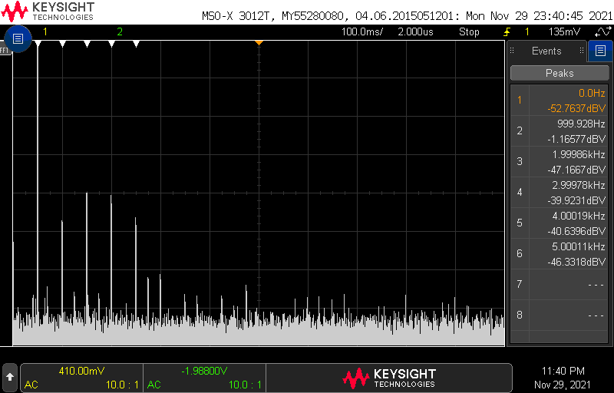

Figure : An oscilloscope measuring the FFT of a 1kHz sine wave using the Search function.

We want to record the harmonics of the input sine wave from Figure 2 as the values in the dB column of Table 1. When you do this you should:

* Ignore any of the Peak frequencies in Figure 2 which are not a close integer multiple of the input frequency.
* If the oscilloscopes reports two peaks at a single harmonic frequency, choose the larger of the two. That is, choose the dB value which is closest to 0dB.
* Round your values to 2 significant figures

The values in the dBc column of Table 1 are computed for as the difference in decibels between the harmonic to the carrier. So the dBc value for the second harmonic at 2kHz is -47dB – (-1.2dB) = -46dB (round to 2-significant figures). Using Equation 5 we can convert this into the ratio of powers as 10-46/10 = 2.6*10-5. Use the information in Figure 2 to complete the remaining rows of Table 1.

Table : The height of the fundamental and harmonics in Figure 2 transformed into the ratio of power of the individual harmonic to the carrier.

|  |  |  |  |  |
| --- | --- | --- | --- | --- |
| Harmonic | Frequency | dB | dBc | 10dBc/10 |
| 1 | 1kHz | -1.2 | 0 | N/A |
| 2 | 2kHz | -47 | -46 | 2.6*10-5 |
| 3 | 3kHz | -40 | -39 | 1.3*10-4 |
| 4 | 4kHz | -41 | -40 | 1.1*10-4 |
| 5 | 5KHz | -46 | -45 | 3.3*10-5 |

Finally, you need to use Equation 7 to convert the values in the 10dBc/10 column to THD. This process is started in the equation below, complete the computation and find the THD for the FFT shown in Figure 2.

$$THD=100*\sqrt{2.6*{10}^{-5}+1.3*{10}^{-4}+… }$$

Measuring THD for Audio Amplifier

Configure your lab bench test and measurement equipment to provide power to your Audio board with power and an input signal and measure the THD of the output. When complete, your setup should look like Figure 3.

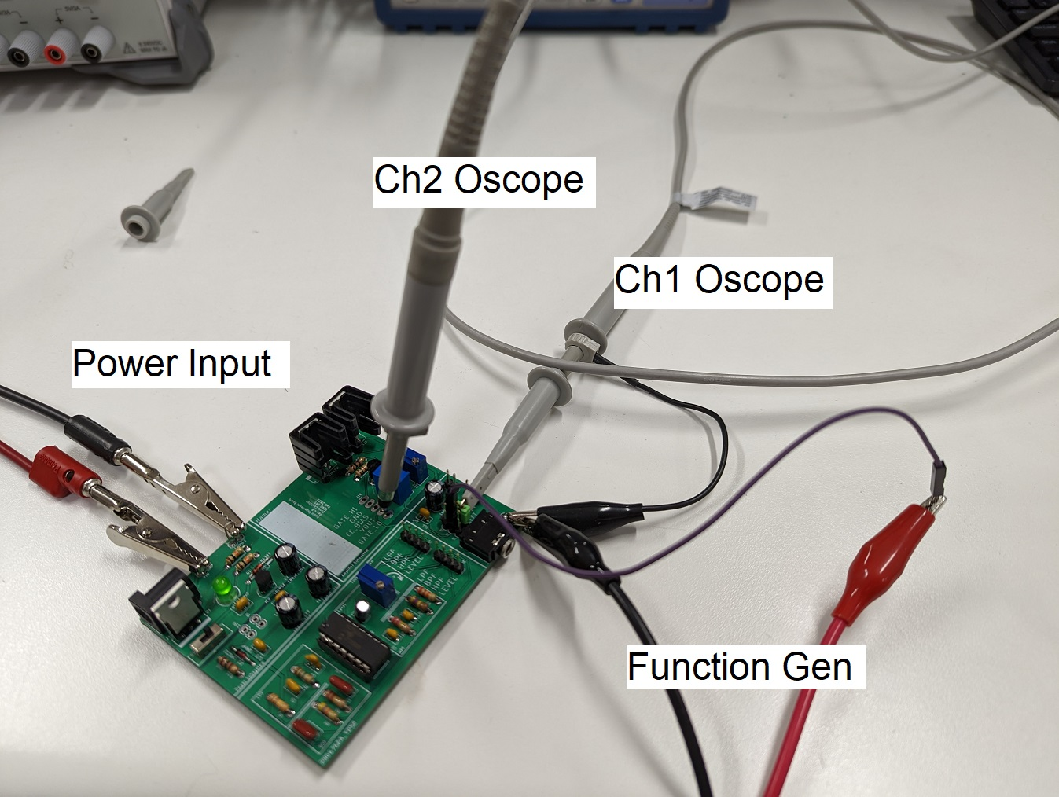

Figure : The setup to measure the THD of the loaded Audio board output.

Configure your power supply as follows:

* Voltage: 12V
* Current: 0.5A
* Disable the power supply output
* Connect leads to Audio Board power input (Vin and GND adjacent to DC jack)

Configure Ch1 of the function generator as follows:

* Waveform: Sine
* Frequency: 1.0kHz
* Amplitude: 0.5V
* Offset: 0V
* Disable function generator output by pressing the **[OUTPUT]** key for CH1 (the output light should be off),
* Connect function generator cable to Ch1,
* Connect red clip of cable to AMPIN of Audio board using a male/female jumper wire,
* Connect black clip of cable to a convenient GND clip.

Configure the oscilloscope as follows:

* Attach 2 oscilloscope probes to Ch1, Ch2,
* Connect Ch1 probe to AMPIN pin using male/female jumper wire,
* Connect Ch2 probe to VOUT,
* Attach the black ground clip of either Ch1 or Ch2 oscilloscope probe to a ground loop on the Audio board. Note, you only need to connect one ground clip as both GND clips are electrically connected to earth GND, so one suffices,
* Configure your oscilloscope as follows:

|  |  |
| --- | --- |
| Horizontal (scale) | 1ms |
| Ch1 | AMPIN |
| Ch1 (scale) | 0.2V/div |
| Ch1 (coupling) | DC |
| Ch2 | VOUT |
| Ch2 (scale) | 2V/div |
| Ch2 (coupling) | AC |
| Trigger source | 2 |
| Trigger slope | ↑ |
| Trigger level | 0V |

Power up the Audio board and then apply the input signal. You should see a pair of sine waves shown in Figure 4.

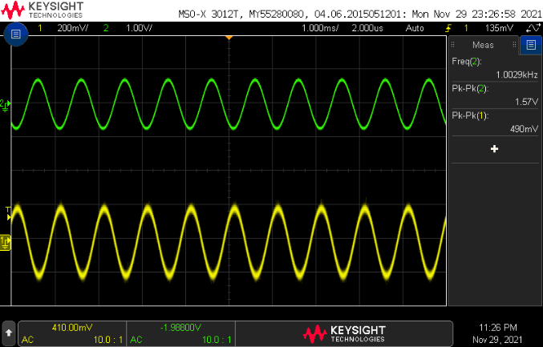

Figure : The input to the Audio board on Ch1 and the output on Ch2.

Only when you have a clear display of the time domain waveform should you start looking at the frequency domain representation. Add the FFT to the oscilloscope as follows:

* [FFT] → Source: → 2
* [FFT] → Display: → Average
* [FFT] → #Average: → 8
* [FFT] → Span → 10 kHz
* [FFT] → Center: 5 kHz
* [FFT] → More FFT
* [FFT] → Vertical Units→ Logarithmic
* [↑ Back] [↑ Back]
* Change the Horizontal scale from 1ms to 100ms. Note how FFT peak narrow.
* Remove the Channel 1/2 trace by pressing the illuminated “1/2” twice. Note, the waveform does not need to be present for the FFT function to work,
* Use the knobs to the right of the FFT button to
  + FFT scale 20dB/div
  + FFT offset -40dB

Next configure the oscilloscope to directly measure the peaks of the FFT using the Search feature. Press this button then configure the oscilloscope as follows:

* [Search] → Search: → Frequency Peaks
* [Search] → Max #Peaks: → 8
* [Search] → Threshold→ -60dB
* [Search] → Excursion→ 20dB
* [Search] → Results Order→ Freq Order
* [↑ Back]

You should see an image very similar to Figure 5 on your oscilloscope display. **Pro-tip, use the RUN/STOP button on the oscilloscope to freeze the display so that you can more easily read all the values without having them jump around.** Note, since we have configured the FFT for a span of 20kHz, each of the 10 horizontal divisions on the oscilloscope is 2kHz wide.

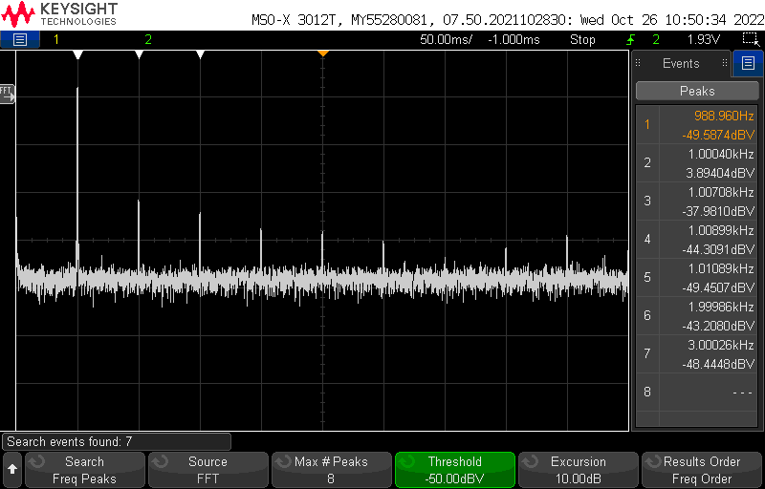

Figure : The FFT of the Audio board output when supplied with a 1kHz 0.5V sinusoidal input.

# Use the information from Figure 5 that you have on your oscilloscope to fill in the information in the thd spreadsheet posted on the Canvas page. In order to assist your understanding of how to fill in the table, I’ve put the values from Figure 5 in the 1kHz, 0.5V cells. Replace these values with those you find using your Audio board. Some notes about the thd spreadsheet,

# Yes, you will have to perform 15 measurements of the THD. This is why it is worth the time automating the peak measurement using the Search function. You may want to change the FFT setup. If your Search values differ from these you may have an issues with your CE_BIAS setting.

|  |  |  |  |  |  |
| --- | --- | --- | --- | --- | --- |
| Frequency | Time Base | FFT Span | FFT Center | Search Threshold | Search Excursion |
| 470 Hz | 200 ms | 4 kHz | 2 kHz | -70 dBV | 20 to 35 dB |
| 1 kHz | 100 ms | 10 kHz | 5 kHz | -70 dBV | 20 to 35 dB |
| 4.7 kHz | 50 ms | 40 kHz | 20 kHz | -70 dBV | 20 to 35 dB |

* You should enter -100 in the thd worksheet for any harmonics that do not appear in the Peaks area.
* You will have to figure out the excel functions to compute the THD using Equation 7. You may use ancillary rows and columns to do this. Some excel functions that
  + SUM
  + POWER
  + SQRT
* You will want to use relative, absolute and mixed cell references.
* I was able to compute the THD values in row 19 with one excel formula that I was able to drag into columns D to L. Hint, I had 7 calls to POWER and I filled in the empty cells in each column with a large negative number to make them approximately 0 in the THD computation.

# Turn in:

Make a record of your response to numbered items below and turn them in a single copy as your team’s solution on Canvas using the instructions posted there. Include the names of both team members at the top of your solutions. Use complete English sentences to introduce what each of the following listed items (below) is and how it was derived.

* Table 1
* Completed thd table with graph